In Class Exercise for Advanced SQL

Create the following table. Ensure that id is a primary key

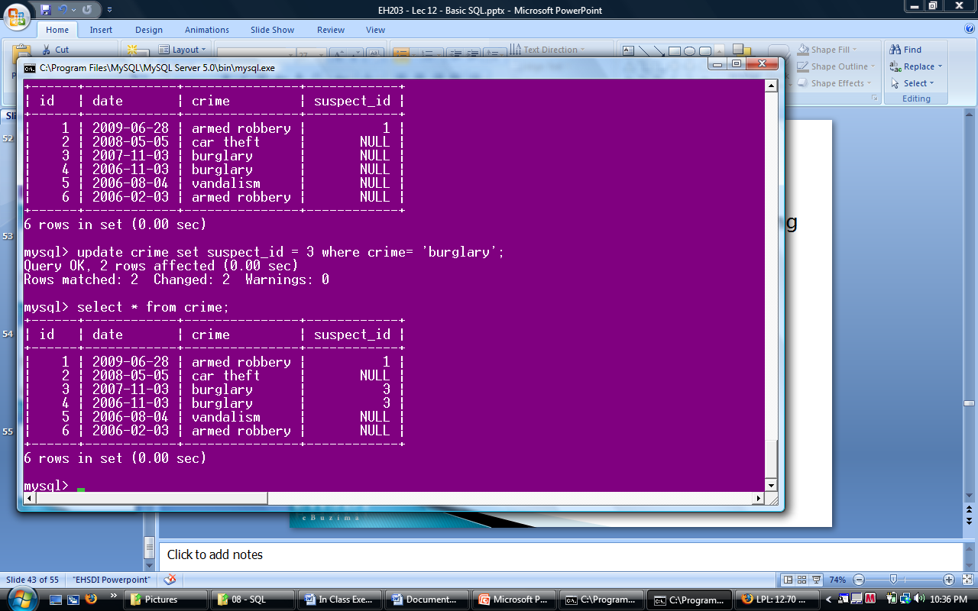

Create the following suspects table. Ensure that id is a primary key

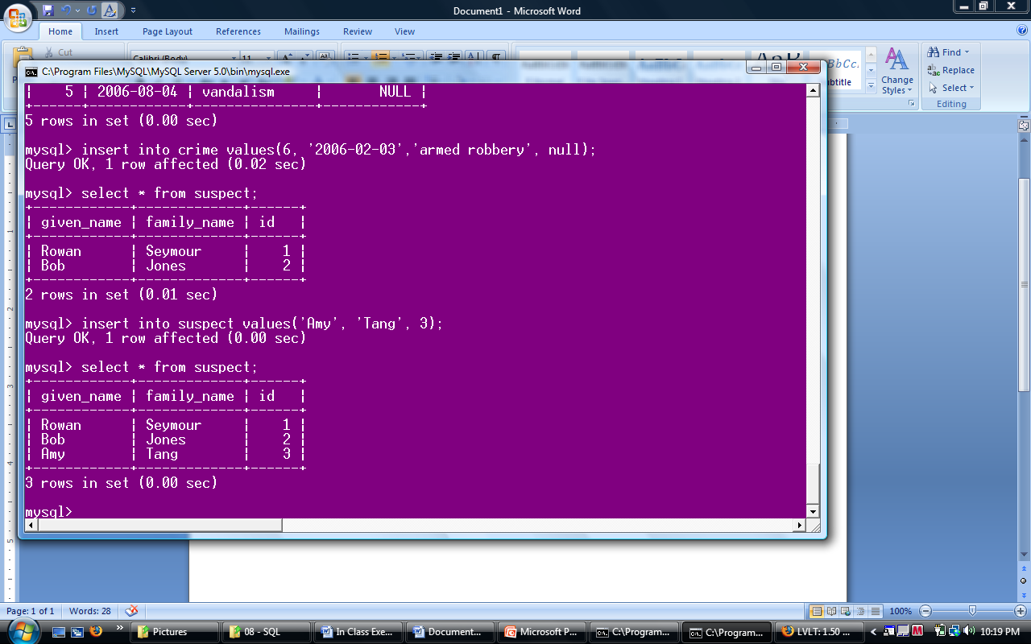

1. Write a query to show the number of records with null values in the suspect_id column
2. Show only the records in the crime table which have a matching id in the suspect table
3. Show all the records in the crime table and only those from the suspect table having a matching id
4. Show all the records from the suspect table and show only the crime records with suspect_ids matching the id field in the crime table

Create the following houses table. Ensure that id is a primary key

` 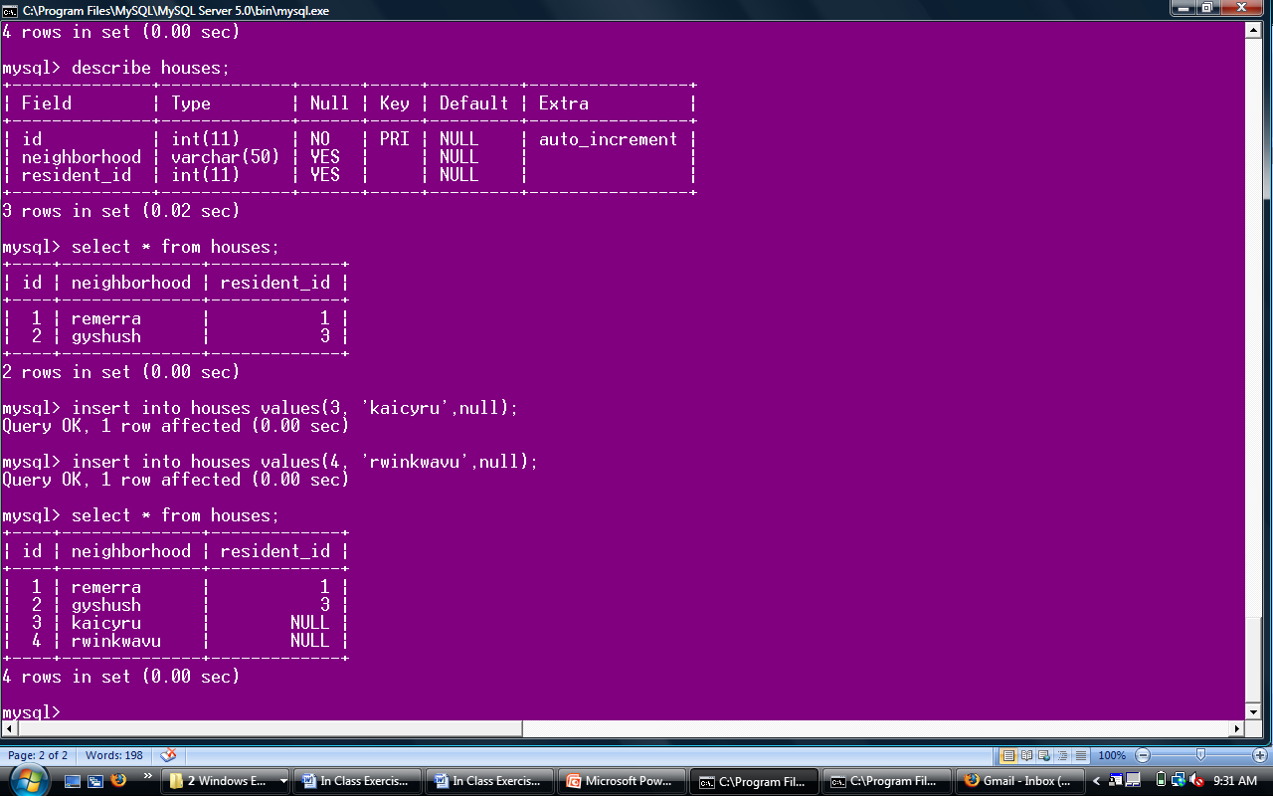

1. Show only the neighborhood that have residents in the suspect table, the suspect’s given name, and only the crimes committed by those residents
2. Show all existing neighborhoods, the residents that live in those houses and all existing crimes
3. Modify the suspects table to ensure the family name will never have a null entry
4. Alter table houses and change the neighborhood column name to village
5. Alter the houses table and add a column to for country
6. Add a constraint to ensure that id is unique